**Experiment 3:** Create a simple cloud software application for Car Booking ReservationSystem using any Cloud Service Provider to demonstrate SaaS include thenecessary fields such as search for cabs, from, to, rental , out station, Packagetype, hours/Days etc.

Step 1: Application Form for Owner Details

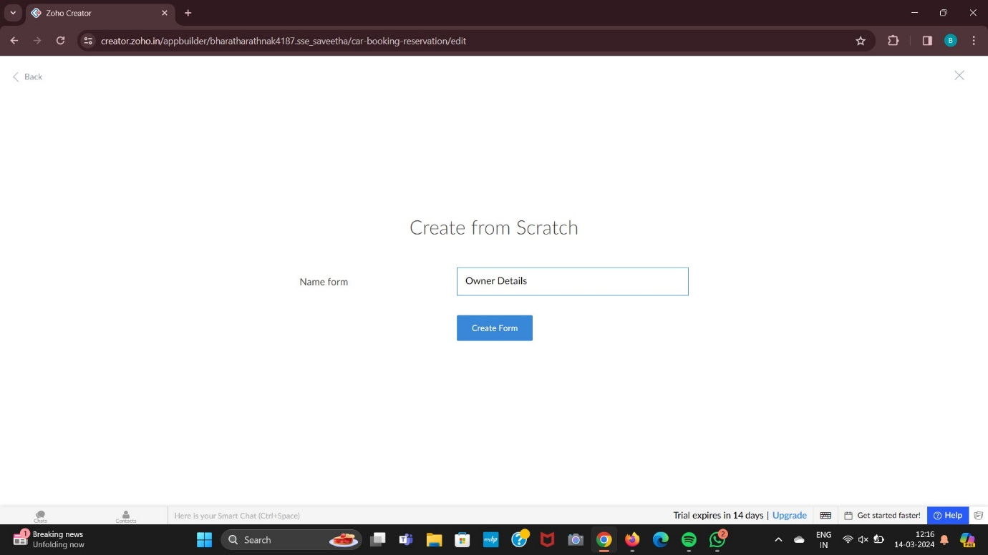

Step 2: Application Form for Customer Details

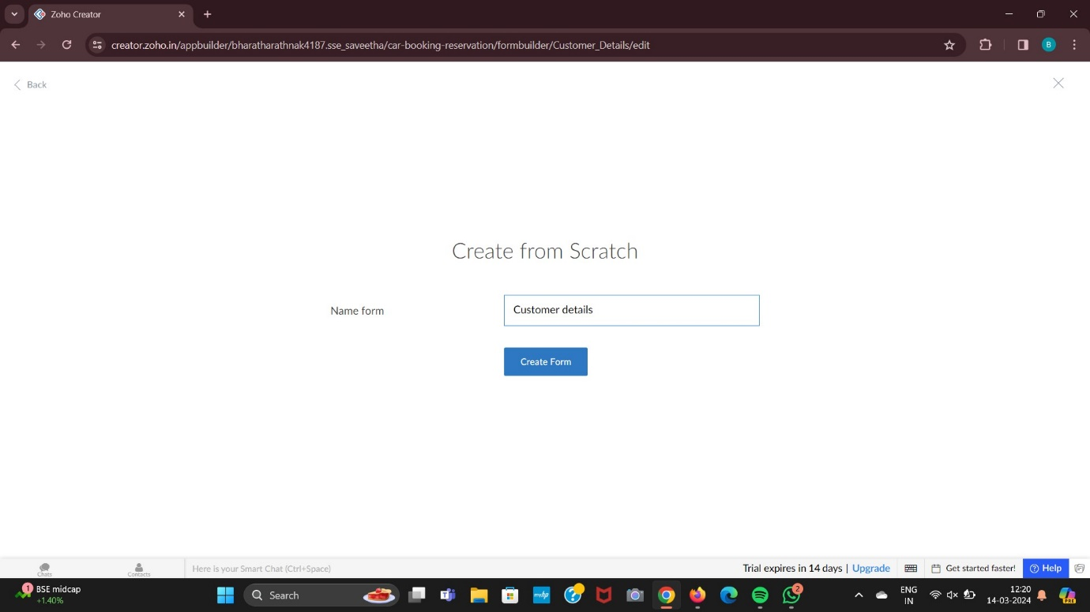

Step 3: Application Details for Car Details

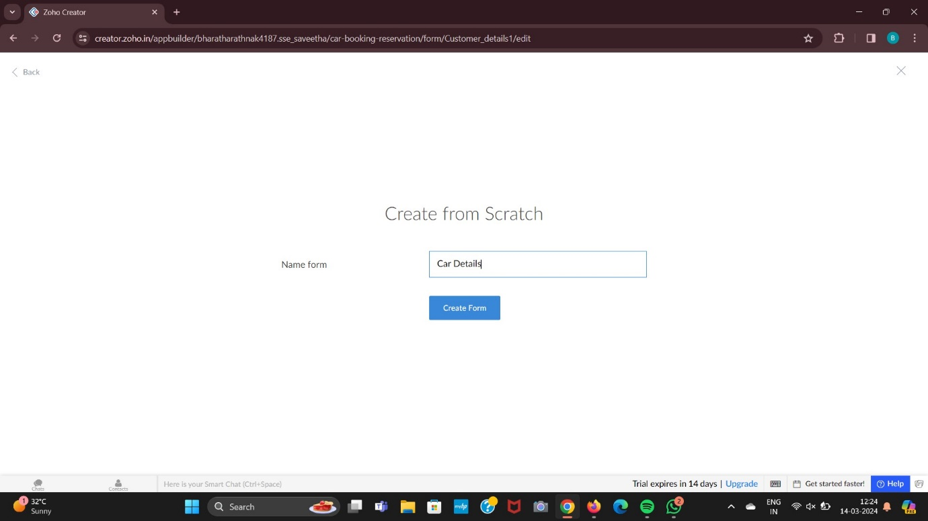

Step 4: Result for Car Details

